**21/09/2021 CD ONSPOT 3 2019103573**

**EXCERSISES**

**1.Write a regular definition to display a line of string for following lex:**

**a)All strings of digits at most one repeated digit.**

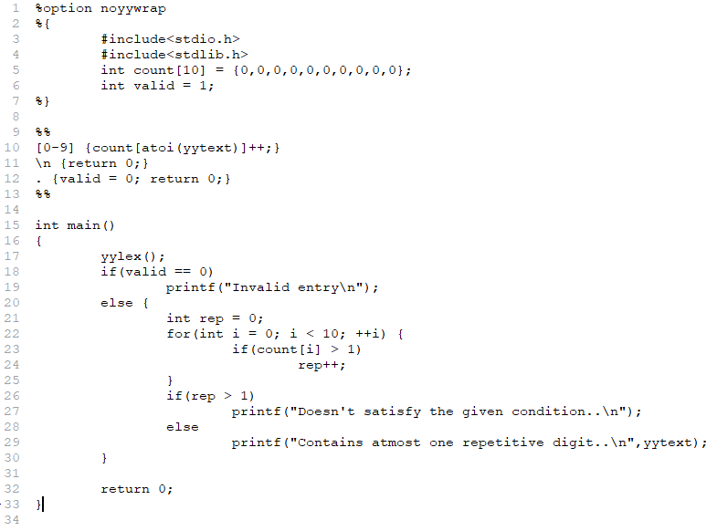**Code :**

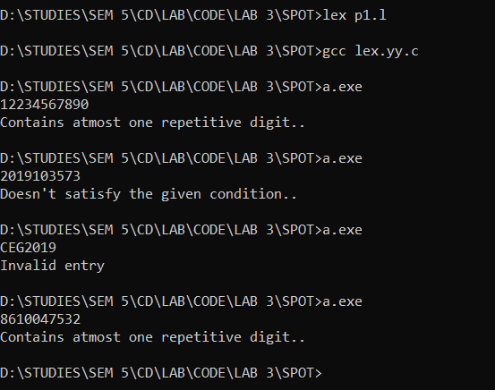**Output :**

**b)All string of a’s and b’s with an even number of a’s and odd number of b’s.**

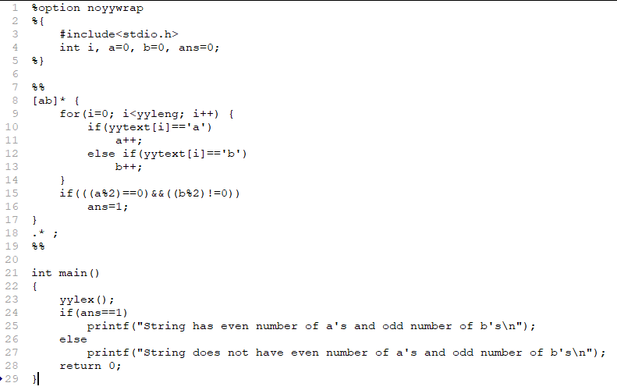**Code :**

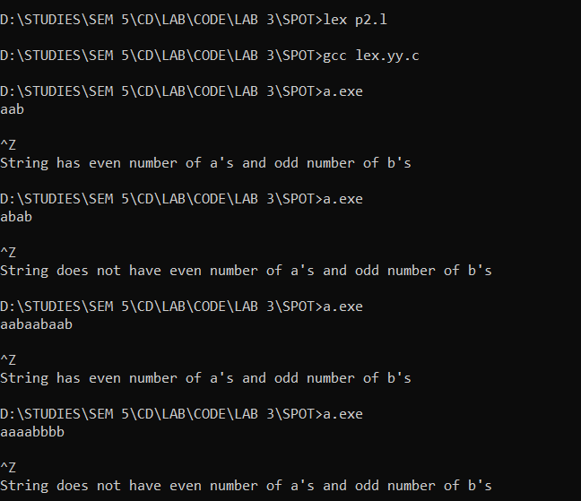**Output :**



**c)All strings of lower case letters that contain 5 vowels in orders.**

**Code :** 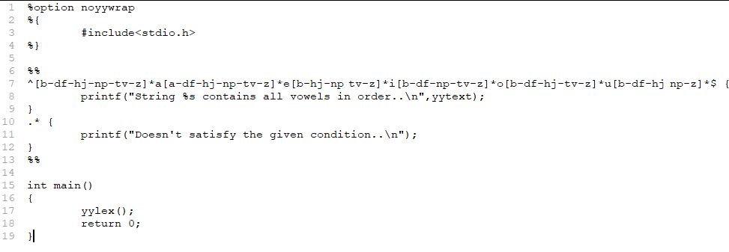

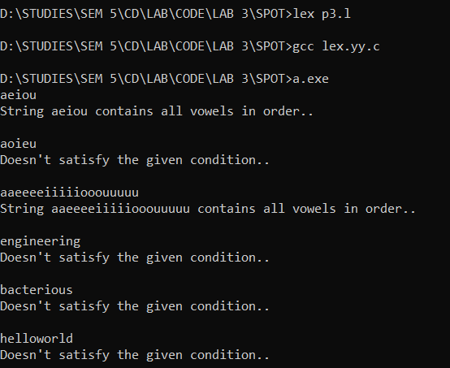**Output :**



**2.Write a lex program to match any string of one or more digits with an optional prefix of + or -**

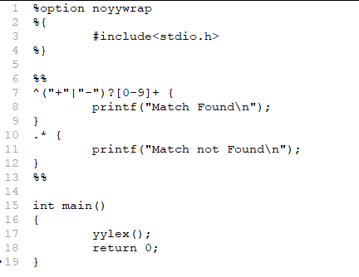**Code :**

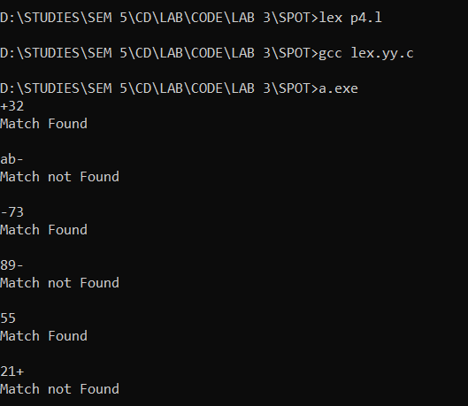**Output :**